

**European School Luxembourg 2**

**Behaviour Policy**

* **Nursery and Primary Cycles -**

Contenu

I. Introduction and aims 3

II. Policy structure 4

III. Golden Rules of the European School Luxembourg 2 5

IV. Code of Conduct 6

V. Harmonised golden rules 7

VI. Behavior management system 8

VII. Anti-bullying Policy and Peer mediation 9

Appendix 1 : Code of European School Luxembourg 2 Behaviour agreement 11

Appendix 2 : reflection forms 13

Appendix 3: letter to parents 15

# Introduction and aims

This policy has been developed with the aim of providing teachers, parents and all staff with comprehensive guidance on the promotion of the desired behavior of children at the European School, Luxembourg 2 and to clarify the measures taken to guide children towards achieving these aims.

The policy is in line with the general aims of the European Schools: To promote tolerance, cooperation, communication and consideration for others throughout the school community and beyond.

By following this policy, we expect **children** to:

* feel safe at school
* be engaged in their learning
* strive to be the best they can be
* arrive at school on time every day
* ensure that they are fully prepared for school
* treat others with respect and listen to their ideas
* cooperate with others
* build positive relationships with others
* respect the school's resources and environment
* respect the personal space of others
* follow the rules and values of the school
* be proud to be a pupil of the European School Luxembourg 2

Role of the **teachers:**

* create a culture of respect for all people
* promote positive behaviour in school at all times
* provide a safe,stimulating and positive environment where all children are valued
* provide positive role models at all times
* form positive relationships with parents and keep them informed of child’s development
* implement the school’s rules, values, rewards and consequences fairly and consistently
* Keep parents informed of child’s development

Specifically, the success of this policy is also dependent on the full and consistent cooperation of all parents.

Role of the **parents**:

* show respect for all members of the school community
* communicate respectfully with school staff
* ensure children attend regularly and are punctual, ensuring absences are authorised
* fully support positive behavior in their children through praise and encouragement
* support the school when dealing with poor behavior
* actively discuss the code of conduct with them
* inform the teacher/the school of any issues or concerns which may affect behavior in school
* collaborate and cooperate with the teachers/ the school when there are behavior problems identified
* work in collaboration with staff to support their child, including attendance at meetings and events
* support the school values, rewards and consequences

# Policy structure

These individual building blocks interlock and form the framework for our school's Behavior Policy:

|  |  |
| --- | --- |
| **Golden rules of the European School Luxembourg 2:** | The golden rules at the European School Luxembourg 2 are linked to our overall Behavior Policy. |
| **Code of Conduct:** | The Code of Conduct explains the golden rules of our school, gives examples of behavior to follow and avoid and is a simple contract between home and school. |
| **Harmonised golden rules:** | The harmonised golden rules provide examples of different rules around the school that are harmonised with the golden rules. |
| **Behaviour management system:** | The Behavior management system gives precise information on what action will be taken if a student does not follow the school's golden rules. |
| **Anti-bullying Policy:** | The Anti-bullying Policy may need to be followed for more serious behavioral breaches. |

The annexes contain all relevant documents required for the implementation of the behavior policy of European School Luxembourg II.

# Golden Rules of the European School Luxembourg 2

These rules are simple and universal and are intended to simplify the many codes that exist in and around the school.

> Behave well and Learn!

> Be respectful!

> Look out for safety!

> Take care and be responsible!

You should use these five words:

- Hello

- Goodbye

- Please

- Thank you

- Excuse me



# Code of Conduct

The pupils of the European School Luxembourg 2 have the right to an education that gives them every opportunity

to reach their full potential. The school management, teachers, support staff - in other words, the whole school

community - are there to create the conditions for this to happen.

The Code of Conduct at the European School Luxembourg 2 provides simple examples of behavior that we expect

students to follow the golden rules in every aspect of school life.

|  |  |
| --- | --- |
| **Golden Rule** | **Examples of behaviour** |
| **Behave well and learn!**  We learn and behave in such a way that all pupils can be together in harmony at school. | • Come to school on time.    • Be prepared and always try your best in class.  • Bring in all the things you need to learn in class each  day.  • Do all homework on time and as well as you can.  • Work well with other students in your class.  • Follow instructions from teachers and supervisors.  • Eat lunch quietly and calmly. |
| **Be respectful!**  We talk and behave in a polite and respectful manner. | • Be polite and respectful with all members of our school community.  • Show tolerance towards others.  • Take responsibility for words and actions.  • Be friendly and cooperative.  • Use friendly, appropriate language.  • Deal with problems by talking to each other. |
| **Look out for safety!**  We look out for our own safety and the safety of all members of the school community. | • Be in the right place at the right time.  • Move around carefully.  • Walk inside school buildings quietly and calmly. |
| **Take care and be responsible!**  We take responsibility for our personal belongings, school property, property of other students and our environment. | • Take care of your personal belongings and other people’s property..  • Treat school property well.  • Throw your rubbish in the waste bin.  • Do not tear leaves from the trees in the playground. |

At the beginning of each school year, students and parents will receive a copy of this behavior policy and will be asked to remember and sign that they agree with them and will make every effort to follow them after the teacher has discussed this with the students in class.

The following behaviour is unacceptable:

• physical violence

• vandalism

• bullying, threatening behavior

• use of swear words

• disruptive behavior in class, during lining up or in the corridor

• using/ bringing dangerous items (like matches, sharp things as knife etc.)

• using a mobile phone during school hours

# Harmonised golden rules

The golden rules are intended to serve as guiding principles for all behaviour at the European School Luxembourg 2. This makes it easier for both staff and pupils to remember and implement them. However, certain areas of the school or certain times in the school day require specific guidance for the children. All of this guidance has been simplified under the headings of the four golden rules. This means that:

• if the child does not remember the specific detail, he/she can still be reminded of appropriate behaviour by pointing out the correct golden rule;

• other examples of required behaviour that are not specifically mentioned in the four golden rules can still be encouraged by referring to the four golden rules;

|  |  |  |  |  |
| --- | --- | --- | --- | --- |
|  | **Learn and behave well !** | **Be respectful !** | **Look out for safety !** | **Take care and resonsability !** |
| **In the playground** | Play kindly and fairly with other children. I follow all adults’ instructions when play time has finished. | Be respectful to everyone. Listen to all adults and follow their instructions. | Play safely in the playground and be aware of others. | Take care of your own, other people’s and school property.  I keep the playground  clean and tidy by putting rubbish in the bin. |
| **In the canteen** | I sit in my place until it is time for me to leave.  I eat calmly and taste a  little bit of everything. | I listen to and follow instructions from adults. | I walk calmly into and out of the canteen. | I handle cutlery and crockery carefully and quietly. |
| **In the library** | I use my time in the library to read, choose a book or listen to a story.  *It is not allowed:*  *- To eat or drink in the* *library*  *- To run around in the library*  *- To write into the books*  *- To touch books with dirty or*  *greasy hands* | I am polite to the librarian if I need to ask for help.  I use a quiet voice. | I walk calmly in the library. | I put books back where they belong.  I don’t eat food or  drink because that can  spoil the books.  I don’t write into the books.  I hang up my coat and take off my shoes to protect the library. |
| **In the washrooms** | I wash my hands with soap and dry with paper. | I flush the toilet when  I am finished. | I don’t play in the toilets. | I don’t waste water or paper.  I throw used paper towels in the bin. |
| **In the gym halls** | I try to learn, just like I do during classroom lessons.  I listen to teachers and follow instructions carefully. | I am a good loser and show respect even if I have lost in a match. | I always wear the correct footwear. | I return used equipment back where I found it.  I use gym equipment only  in the gym.  I always have my PE kit and I take it with me at the end  of the lesson. |
| **In classrooms** | I always try to learn something new, even when it seems difficult.  I follow the class rules | I share material and other equipment fairly with others. | I enter and leave the room calmly. | I show attention to others. |

# Behavior management system

When children are unable to follow the Golden Rules, the European School Luxembourg 2 aims to take consistent and fair action, across all language sections. In order that appropriate action can be taken, the motives for offending behavior are given in the following list as well as the measures to be followed. The examples given are not exhaustive. Teachers can develop their own systems for promoting positive behavior in the classroom, but the following framework for dealing with problems should be applied consistently.

|  |  |
| --- | --- |
| Motives | Consequences |
| prohibited objects (smartphone…) | 1. object confiscated and returned at the end of the day 2. in the case of repeating, the object will be confiscated and returned to the parents who must come and collect it |
| unintentional physical assault on a classmate during break time | - request a verbal apology  - if necessary, accompany to the nurse |
| insulting a fellow student | 1. requesting a verbal apology 2. if repeated, information to the parents 3. in case of repeating, partial deprivation of break time 4. if repeated, convocation to ADDNP* for follow-up** 5. if repeated, a meeting with the DDNP* for follow-up |
| intentional physical harm to a fellow student | 1. request for a detailed apology and explanation (in writing for older students) 2. if repeated, information to the parents 3. if repeated, sanction 4. if repeated, convocation to ADDNP for follow-up 5. if repeated, a meeting with the DDNP for follow-up |
| insolence towards an adult | 1. request for a detailed apology (adjusted to the age level) 2. if repeated, information to the parents 3. if the offence is repeated, a meeting with the ADDNP for follow-up 4. if repeated, a meeting with the DDNP for follow-up |
| being in a forbidden place (e.g. being in the corridors during breaks) | 1. oral reprimand 2. if repeated, information to the parents 3. if repeated, sanction 4. if repeated, a meeting with ADAMP for follow-up 5. if repeated, a meeting with the DAMP for follow-up |
| other cases | a specific and adapted response will be provided by the school management. |
|  | *ADDNP :Assistant Deputy Director Nursery Primary  *DDNP: Deputy Director Nursery Primary  **Main steps are: oral warning, written warning, disciplinary council  NB: In any case, the management will decide of the needed meetings to be organized with parents and message to be send to parents. |

# Anti-bullying Policy and Peer mediation

In our school bullying is not accepted. Anyone who is aware of it should make sure that the victim as well as the aggressor is given appropriate help and support.

**What is Bullying?**

Bullying is the use of systematic aggressive behavior against a person who finds it difficult to defend him/herself against the perpetrator(s).

**Repeated** nature of attacks and **power differential** are central features.

**Bullying takes many forms:**

Physical

• Physical bullying includes hitting, kicking, slapping, pinching, biting, poking and choking. It also includes destroying personal belongings.

Emotional

• Emotional bullying refers to the cases where a person is made to feel isolated and ridiculed largely through mechanisms such as being unfriendly, teasing, shouting, mocking, excluding, tormenting and ignoring.

Verbal

• Verbal bullies use words to hurt or humiliate another person. Verbal bullying includes name-calling, insulting, making racist comments, constant teasing and spreading false rumors, trying to convince peers to exclude or reject a certain person or people, and cut the victims off from their social connections.

Cyber

• Cyber bullying is when a child is tormented, threatened, harassed, humiliated, embarrassed or otherwise targeted by another child using the internet, interactive and digital technologies or mobile phones.

**Action to be taken**

The school has chosen a proactive approach in the frame of the KiVa program which make possible to prevent problems from developing by raising awareness and suggesting strategies that promote a positive, supportive environment.

**At a school level**

• Provide for supervision, noting, reporting, investigating and dealing with incidents of bullying behavior

• Give special attention to the school climate so that it reflects respect, tolerance, caring, trust and support.

• All members of the school community have the responsibility not to ignore instances of bullying behavior and to intervene when necessary.

• In some cases KiVa experts’ assistance must be sought.

**At a classroom level**

Each teacher should **raise awareness** of bullying within their class so that:

• Children understand that bullying is unacceptableand not to be tolerated.

• Victims and bystanders understand that they should **report incidents of bullying** to their peers, teachers or parents.

• Bystanders understand that wherever possible they should help / protect their peers whom they see are being bullied.

**Procedure to follow in school when there is a case of bullying**

A meeting is held where **all concerned** (Kiva team member, teachers, school psychologists, Deputy Head and/or Deputy head assistant) decide on the specific reaction of the school to the case in question. All teachers who deal with a child will be informed.

The KiVa team will check all relevant history of the case and determine an appropriate strategy for

• the victim

• the bully

• the rest of the class (if appropriate)

• providing background information, advice, and resources for teachers

• providing background information and advice for parents

Documentation will be kept in the child’s files.

In case of incidents during periscolaires activities or in the buses, information can be shared by PA and School, and if needed followed up.

**Peer mediation**

The aim of peer mediation is to promote conflict resolution between stakeholders through a mediator.

The school is working with SCRIPT to implement this program in our school.

The aim is to train P4 students to become mediators when they become P5 students.

Some Teachers have also been trained in the procedures and issues of peer mediation in order to accompany the students in this process. Similarly, a SCRIPT expert intervenes in the school to train and guide teachers and pupils.

The use of mediation is open to all pupils in the primary cycle.

# Appendix 1 : Code of European School Luxembourg 2 Behaviour agreement

**Code of European School Luxembourg 2**

**Behaviour**

**agreement**

As a student in the European School Luxembourg 2,

I ________________________________________ , __________ agree to

name class

do my best to follow the school rules below:

1. I have necessary classroom equipment ready and always try my best in class.
2. I’m polite and respectful with all members of our school community.
3. I will listen and follow the instructions from teachers and supervisors.
4. I will take care of my personal belongings, school property and property of other students.
5. I will move around calmly and carefully.
6. I will play safely and fairly during break time.
7. I will keep my desk, the classroom and the school grounds clean and tidy.

I am fully informed of the consequences, in case I do not follow the above rules

I have talked with my teacher, classmates and my parents about these rules.

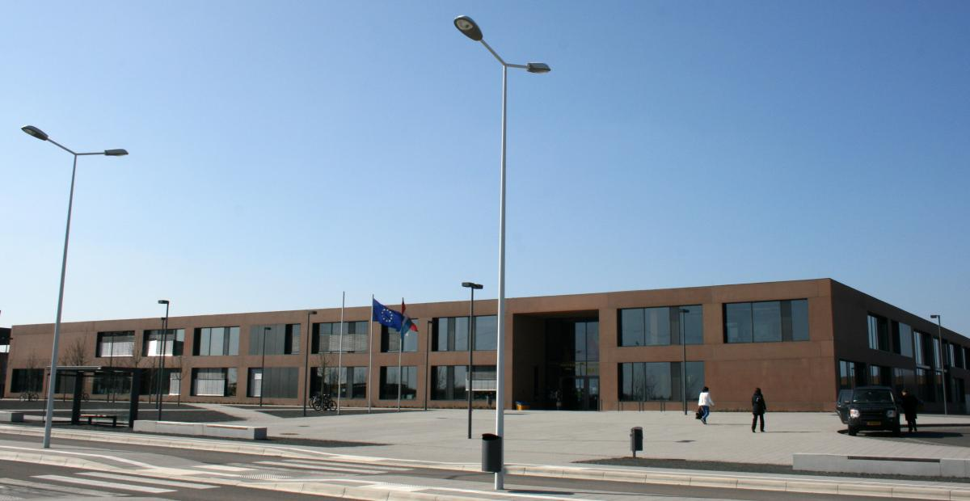

# Appendix 2 : reflection forms

**Reflecting on my actions – Nursery and P1/P2**

*Verbal reflection – teacher notes*

My name: ______

My class: __

This can be used as a writing or speaking / drawing exercise (for the youngest children).

|  |  |
| --- | --- |
| 1. What I have done? | 1. What happened? – Why did this happen? - Impact on me and others |
| 3. How do I feel? | 4. What will I do to change my attitude? |

date: ___ / /_______

Teachers’ signature

Pupil’s signature

**Reflecting on my actions – P3, P4 and P5**

1. 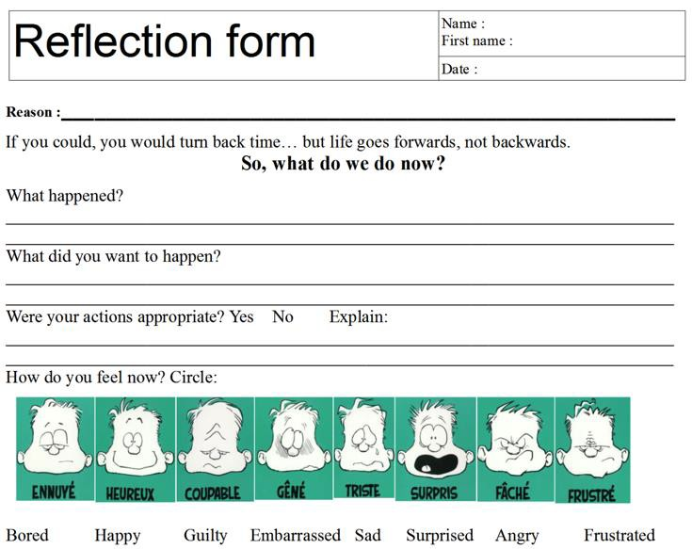

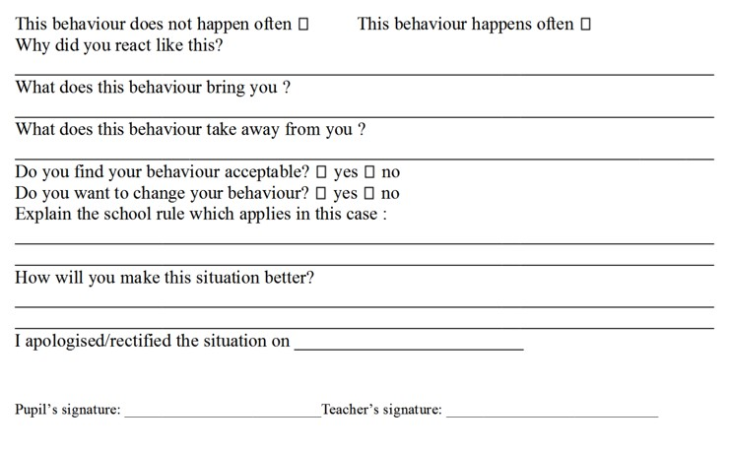

# Appendix 3: letter to parents

Date: _______________________

Dear parents,

Please talk to your child _____________________________________ , _____________

name class

and remind him/her of the following rule/rules:

It is important that all children adhere to our code of conduct and follow our Golden Rules. Please talk to your child about her/his behaviour and remind her/him of the importance of behaving well at school and to respect all rules.

Please complete and sign the letter below, returning it to the class teacher.

To: ___________________________________________

name of class teacher

I have discussed this behavior with my child and reminded her/him of the importance of good behavior in school at all times.

Additional comments:

Signature(s):